# FSPM Assignment 2

## Step 1 Calculation of Functional Points

External Inputs:

1. User Related Inputs like account, password, designation.
2. Registration of accounts.
3. Administrator related inputs (will inherit user capabilities).
4. Booking detail inputs.
5. Stock detail inputs.

External Outputs:

1. Report Generation for different modules like stock,transactions,payments based on time frame for sales.
2. Checkout Bill generation.

External Inquiries:

1. Administrator Views.
2. User Views.
3. Searching options for stock,transitions,bookings.

Internal Logic Files:

1. Searching algorithm logic.
2. MVC architecture.
3. Models for objects.
4. Backup data files to servers.

External Interface Files:

1. Busniess Logic of EMS.

## Step 2 Calculation of Weighting Factors

|  |  |  |  |  |
| --- | --- | --- | --- | --- |
| EI(1)=3(Simple) | EO(1)=5(Average) | EIQ(1)=4(Average) | ILF(1)=7(Simple) | EIF(1)=5(Simple) |
| EI(2)=3(Simple) | EO(2)=4(Simple) | EIQ(2)=3(Simple) | ILF(2)=7(Simple) |  |
| EI(3)=3(Simple) |  | EIQ(3)=3(Simple) | ILF(3)=7(Simple) |  |
| EI(4)=3(Simple) |  |  | ILF(4)=10(Average) |  |
| EI(5)=3(Simple) |  |  |  |  |
| Count=15 | Count=9 | Count=10 | Count=31 | Count=5 |

Count Total=> 70

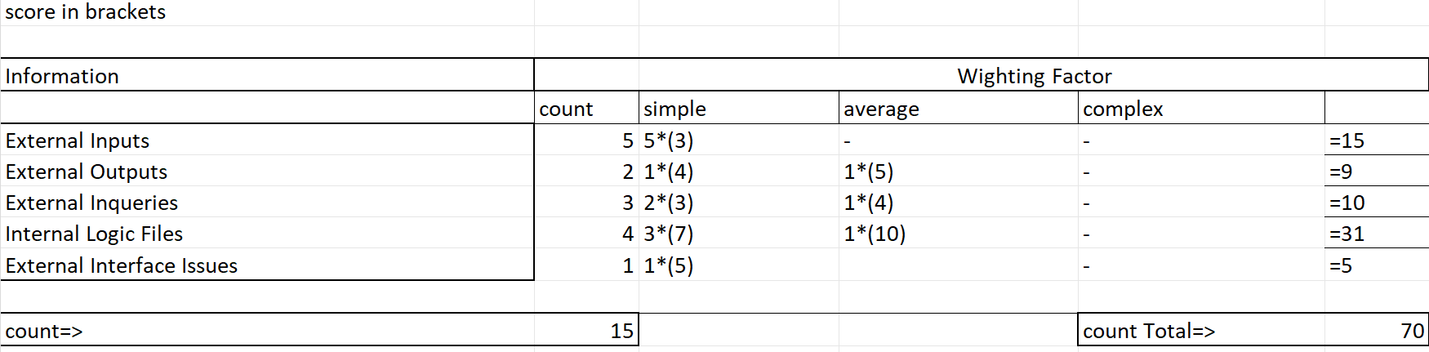

## Step 3 : Complexity Adjustment Values

1. Does the system require reliable backup and recovery? => 5
2. Are data communications required?=> 0
3. Are there distributed processing functions?=> 0
4. Is performance critical?=> 1
5. Will the system run in an existing, heavily utilized operating environment?=> 0
6. Does the system require online data entry?=> 5
7. Does the online data entry require the input transaction to be built over multiple screens or operations?=> 2
8. Are the master files updated online?=> 5
9. Are the inputs, outputs, files or inquiries complex?=> 0
10. Is the internal processing complex?=> 0
11. Is the code designed to be reusable?=> 2
12. Are conversion and installation included in the design?=> 2
13. Is the system designed for multiple installations in different organizations?=> 0
14. Is the application designed to facilitate change and ease of use by the user?=> 5

Total sum for VAF=>27

## Step 4: Computation of Functional Points

Weighted Functional Points= Count Total for FP * (0.65 + 0.01 * (Value Adjustment Factor))

Weighted FP= 70 * (0.65 + 0.01 * (27))

Functional Points = 64.4 rounded up to 65.

## Step 5: Estimation of Lines of Code

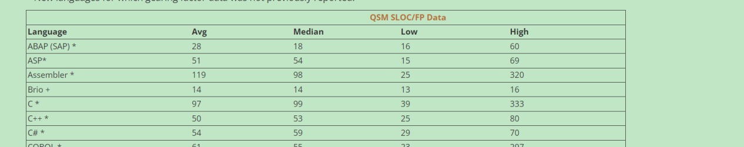

So:

Lines of code= Weighted FP * Avg SLOC

Lines of code= 65*54

Lines of code=3510

So 3.51 kLoc

## Step 6 : Implementation of Intermediate COCOMO

My system is qualifying for Organic mode. It is an inventory system, with a small project team, less innovation required, and has a stable development environment. Product size also lies between 2-50 kLoc.

Effort (E) = a x (Size)^bx C

Where a=2.4 and b=1.05, C is cost drivers.

Size=kLoc

So E=2.4 x (3.51)^1.05 x C

### Cost Drivers.

#### Product Attributes.

* RELY: Very Low. The system is straight forward and a basic centralized system. There are no data connections, high volume data transfer so the factor is Very Low (0.75).
* DATA: Low. There is not a high frequency data; nor very big size; there is less expectation for data to change so a low factor.(0.94).
* CPLX: Very Low. There is a low complexity factor since the requirements are plain, won’t change, and very straight forward. So very low (0.7) complexity factor.

#### Computer Attributes

* TIME: The execution time constraint is nominal(1.0). No hard outlines have been set.
* STOR: The data storage constraint is high(1.06). This is because we do need to make a backup so this means we do have a priority.
* VIRT: There is no need for a virtual machine with it’s volatility. So Low(0.87) factor.
* TURN: There is no hard turnaround restraint. But there is a need for 5 second fetching from database so it can be attributed to a nominal factor(1.0).

#### Personnel Attributes

* ACAP: Being a business person, think my analyst capabilities are nominal (1.0). The analyst is can analyze the business requirements well for such a simple system.
* AEXP: The application experience for the personnel will be high(0.91) as a I have a good experience of making Management systems.
* PCAP: I as a programmer has a good grip on MVC so the rating would be high(0.86).
* VEXP: Again, so such VM is needed so the requirement can be said to be nominal(1.0).
* LEXP: The developers are high (0.95)in C# as I am working a job with it as well.

#### Project Attributes

* MODP: There is no such constraint of the client so we can keep it simple so Low(1.1).
* TOOL: We can use normal software engineering tools however the added data backup can be said to be a little up to date so low(1.1) factor.
* SCED: The schedule is loosely couple not very clear, so very low(1.23).

Cost driver calculation= 0.75x0.94x0.7x1.0x1.06x0.87x1.0x1.0x0.91x0.86x1.0x1.1x1.1x1.23=>0.53008 so 0.53.

So E=2.4 x (3.51)^1.05 x C

E=2.4 x (3.7373) x 0.53= 4.7538 so 4.8 staff-months rounded up.

So 5 staff-months rounded up with UAT perhaps.

The development time expected is:

2.5x( E )^0.38

2.5 x (4.7538)^ 0.38 =>4.520 sp 4.5 months.

Average staff members required:

Effort/Tdev so 4.8/4.5 => 1.0666 so 1 staff-member developer required.

Productivity required from the staff person is:

Size/Effort so 3510/4.7538 => 738.35 sp 739 lines of code per staff-month.

This means, me as a person can complete this job in 4.5 months where I will need to write almost 739 lines of code per staff-month

If I demand a for myself at least 60,000 PKR for coding, 5,000 for electricity charges, 5,000 for food supplies it means my staff-month cost is 70,000 PKR.

Now for the time of 4.5 months; I can quote the software for 450,000 PKR.

## Results

|  |  |
| --- | --- |
| Average lines of code expected | 3.51k Lines of Code |
| Effort in staff-months | 4.8 so 5 Staff-Months |
| Time of development | 4.5 Months |
| Developers Required | 1 developer required |
| Productivity expected | 739 Lines of code per staff-month |
| Cost Associated | 450,000 PKR |